ASSIGNMENT 2 – CO2

CO2 Coverage: Design C++ programs by applying functions and object-oriented concepts – function prototyping, call by reference, return by reference, inline functions, default arguments, function overloading, specifying a class, member functions, access specifiers, arrays within a class, static data members and member functions, arrays of objects and friend functions.

Nature of Assignment: Individual Duration: 1 Week
Total Marks: 50
Submission Date: 31/10/2026
Bloom’s Levels Assessed: K5 – Evaluate (every task in this assignment is at K5 level) Mandatory Execution and GitHub Submission
- Every student must individually execute every task in this assignment, including all “Complete the Code” programs.
- Create a GitHub repository named DSA01-<RegisterNumber>-Assignment2 and share it with the course faculty (public, or private with the faculty added as a collaborator).
- Keep one folder for each task (for example: Task01, Task02 … or Q1, Q2 …), containing the C++ source files, input files and output screenshots.
- Include a README.md with your name, register number, compiler and version (for example g++ 13), the exact g++ command used to compile (for example g++ -std=c++17 - Wall -Wextra), the steps to run each program, and a short note of the result of each task.
- Commit your work progressively – at least one commit for each task. The commit history will be checked; a single upload of all files on the last day will not be accepted.
- Submit the GitHub link below and on the cover page of your report. An assignment submitted without a working GitHub link will not be evaluated.

GitHub Repository Link: https://github.com/nazma824/DSA0117
How to Answer the Additional Questions
Complete the Code: Copy the given code into your repository, replace every TODO with working code without changing the rest of the program, execute it and compare your output with the expected output.

Predict the Output: Write the exact output of the given program before running it. Then run it and explain every difference between your prediction and the actual output, using the C++ rules involved. Predictions written after running the program will not be credited.
Alternative Concept and Complexity Analysis: Describe how the solution would change if the alternative concept were used, with code or pseudocode, and analyse and compare the time complexity and space complexity of both solutions using Big-O notation, supported by your own measurements wherever possible.

Q1 – Call by Value, by Reference and by Pointer 6 Marks Bloom’s Level: K5 – Evaluate
Problem Context – Hostel Fee Concession Updater
The hostel office applies concessions (merit 10%, sports 15%, single parent 25%) to students’ fees. A function written to apply the concession appears to work when its result is printed inside the function, but the fee stored for the student never changes.
Your Challenge
Write the concession function three ways – passing the fee by value, by reference and by pointer. Before running, predict the stored fee after each call, then verify.
Inquiry
Explain where each version stores its parameter, why only two of them change the caller’s fee, and when a const reference parameter should be used instead.
Design Decision
Several concessions may apply to one student. Decide whether the function should change the fee in place or return the new fee, and defend your choice.
Predict the Output
Write the exact output of the program below BEFORE running it. Then compile and run it, and explain every difference between your prediction and the actual output.
#include <iostream>

void change(int a, int& b, int* c)
{
a += 10;
b += 10;

*c += 10;
}

int& bigger(int& p, int& q) { return p > q ? p : q; }

void show(int x, int y = 5, int z = 10) { std::cout << x + y + z << ' '; }

int main()
{
int a = 1, b = 2, c = 3; change(a, b, &c);
std::cout << a << ' ' << b << ' ' << c << '\n';

bigger(a, c) = 100;
std::cout << a << ' ' << c << '\n';

show(1);
show(1, 2);
show(1, 2, 3);
std::cout << '\n';
}

My predicted output (write before running):

Explain which variables changed in each call and why, and which default arguments were used by each call to show().
Complete the Code
Complete TODO 1 below so that the caller’s fee is changed, and execute the program. #include <iostream>

void applyByValue(long long fee, int percent)
{
fee -= fee * percent / 100; // changes only the local copy
}

void applyConcession(long long& fee, int percent)
{
// TODO 1: Reduce the caller's fee by percent using integer arithmetic (call by
// reference)

}

int main()
{
long long hostelFee = 45000; applyByValue(hostelFee, 10);
std::cout << "after call by value : " << hostelFee << '\n'; applyConcession(hostelFee, 10);
std::cout << "after call by reference: " << hostelFee << '\n';
}

Expected output:
after call by value : 45000

after call by reference: 40500

Explain why the call by value leaves the fee at 45000. Alternative Concept and Complexity Analysis
If the concession function returned the new fee (long long applyConcession(long long fee, int percent)) instead of changing the fee through a reference, what would the solution be?
Analyse the time (O(1) in all versions) and the space copied per call for a long long and for a large Student object passed by value, by reference and by const reference.
Evidence Expected
Three implementations, predictions before execution, observed results and a defended interface design.

Q2 – Return by Reference and Its Dangers 4 Marks Bloom’s Level: K5 – Evaluate
Problem Context – Examination Marks Register
The marks register keeps the marks of a class in an array. A function returns a reference to the highest mark so that a moderation of +2 can be applied directly to it. A second function returns a reference to a local variable.
Your Challenge
Implement both functions and show:
- How returning a reference lets the caller change the array element (and even use the call on the left of =)
- What the compiler warns about when a reference to a local variable is returned, and why using it is undefined behaviour
- The difference between returning a reference, returning a const reference and returning a copy

Changed Condition
The register is now stored in a std::vector that may grow. Explain why a reference obtained before the vector grows may become invalid.
Alternative Concept and Complexity Analysis
If the highest mark were returned as an index (int) or as a pointer (int*) instead of a reference (int&), what would the calling code look like? Analyse the time to find the highest mark

(O(n) in all three) and the space (O(1)), and compare the safety of each when the array is later replaced by a growing vector.
Evidence Expected
Working functions, compiler-warning evidence, a correct explanation of dangling references and a justified response to the changed condition.

Q3 – Default Arguments and Function Overloading 6 Marks Bloom’s Level: K5 – Evaluate
Problem Context – Courier Charge Calculator
A courier counter charges by weight; express delivery and insurance are optional. The developer wrote charge(double weight), charge(double weight, bool express) and charge(double weight, bool express = false, bool insured = false). The program no longer compiles.
Your Challenge
Explain the compiler error (ambiguous call). Then design the charge functions so that:
- Common calls are short (default arguments)
- Different kinds of input (weight in grams as int, weight in kg as double, a Parcel object) are handled by overloading
- No call is ambiguous

Before execution, predict which function each of six calls you design will select, including charge(2) and charge(2.0f).
Inquiry
Explain how the compiler chooses among overloaded functions (exact match, promotion, conversion), and why default arguments must be given from the right.
Alternative Concept and Complexity Analysis
If the courier charge took a single Parcel structure with optional fields (or a function template) instead of several overloaded functions with default arguments, what would the solution be? Analyse the time of overload resolution (at compile time, no run-time cost) and the space copied per call, and compare how each design handles a new option.
Evidence Expected
An explained ambiguity, a redesigned set of functions, predicted and observed selections, and a reasoned explanation of overload resolution.

Q4 – Specifying a Class with an Array Inside It 6 Marks Bloom’s Level: K5 – Evaluate
Problem Context – Savings Account Mini-Statement
A bank wants each SavingsAccount object to remember its last 10 transactions for the mini-statement printed at an ATM. Older transactions are discarded.
Your Challenge
Specify the class with private data (account number, balance, an array of 10 transactions and a count) and public member functions deposit(), withdraw() and miniStatement(). Define some member functions inside the class and some outside using the scope resolution operator.
Inquiry
Explain why the array must be private, what happens when the 11th transaction arrives if you shift the array versus use a circular index, and the cost of each.
Design Decision
The bank now wants the last 50 transactions. Decide which design changes least and defend it.
Alternative Concept and Complexity Analysis
If the last 10 transactions were kept in a std::deque (push_back and pop_front), or in a circular buffer with a start index, instead of shifting a fixed array, what would the solution be? Analyse the time to add a transaction (O(k) for shifting k elements versus O(1)) and the space used in each design.
Evidence Expected
A complete class specification, member functions defined inside and outside the class, a justified handling of the 11th transaction and a defended design.

Q5 – Static Members and Arrays of Objects 7 Marks Bloom’s Level: K5 – Evaluate
Problem Context – College Bus Seat Tickets
The college bus has a fixed number of seats. Each BusTicket object must receive the next seat number, tickets beyond the capacity go to a waiting list, and the transport office must know how many seats have been issued without looking at any particular ticket.
Design Starting Point
You are given only the following principle:

Data that belongs to the whole class – not to any one object – should exist only once, however many objects are created.
Your Challenge
Convert this principle into a class design. Determine:
- Which members must be static, and where a static data member must be defined
- Why a static member function cannot use this or a non-static member
- How an array of BusTicket objects is created and initialised
- What happens to the count when tickets are created inside a loop or a function

Test Your Design
Create an array of tickets larger than the capacity and verify the seat numbers and the waiting list.
Predict the Output
Write the exact output of the program below BEFORE running it. Then compile and run it, and explain every difference between your prediction and the actual output.
#include <iostream>

class Token { static int next; int id;

public:
Token() { id = ++next; } int get() const { return id; }
static int issued() { return next - 100; }
};

int Token::next = 100;

int main()

{
Token counter[3]; Token extra;
std::cout << counter[0].get() << ' ' << counter[2].get() << ' ' << extra.get()
<< ' ' << Token::issued() << '\n';
}

My predicted output (write before running):

Explain why the static counter starts at 100 and how many times the constructor ran. Complete the Code
Complete TODO 1 and TODO 2 below using the static members, and execute the program. #include <iostream>
#include <string>

class BusTicket {
static int issued; // shared by all BusTicket objects static const int CAPACITY = 3;
int seat; std::string name;

public:
explicit BusTicket(const std::string& n) : seat(0), name(n)
{
// TODO 1: If fewer than CAPACITY tickets have been issued, increase issued and

// give this ticket the next seat number; otherwise leave seat as 0 (waiting
// list)

}

static int count()
{
// TODO 2: Return the number of seats issued so far

}

void print() const
{
std::cout << name << ": "
<< (seat ? "Seat " + std::to_string(seat) : std::string("Waiting"))
<< '\n';
}
};

int BusTicket::issued = 0; // definition of the static data member

int main()
{
BusTicket trip[4] = {BusTicket("Asha"), BusTicket("Bala"), BusTicket("Chitra"), BusTicket("Dev")};
for (const BusTicket& t : trip) t.print();
std::cout << "Issued: " << BusTicket::count() << '\n';
}

Expected output:
Asha: Seat 1
Bala: Seat 2
Chitra: Seat 3 Dev: Waiting Issued: 3

Create the tickets inside a function that is called twice and explain how the count behaves. Alternative Concept and Complexity Analysis
If the seat counter were a global variable, or were kept in a separate TicketOffice object passed to every BusTicket, instead of a static data member, what would the solution be? Analyse the time (O(1) in all) and the space (one counter in all), and compare the encapsulation and the ability to run two buses at once.
Evidence Expected
A student-derived class design using static members, an array of objects, test evidence and a reasoned explanation of static members.

Q6 – Friend Functions and Inline Functions 8 Marks Bloom’s Level: K5 – Evaluate
Problem Context – Train Journey Planner
A journey planner stores departure and arrival times in a Time class whose hours and minutes are private. It must compute the minutes between two times and decide which time is earlier, and these small functions are called millions of times while planning connections.
Your Challenge
Design the comparison. Determine:
- Why a friend function is needed when the function works on two objects equally
- How a friend function differs from a member function in how it is called and what it can access
- Whether the small functions should be inline, and what inline actually asks the compiler to do
- What would be lost if the private members were made public instead

Correctness Check
Test with times on either side of noon and the same time twice, and verify by hand. Growth Investigation
Measure the time for 10,000,000 calls with and without inline (compile with -O0 and with - O2), and explain the result.
Deployment Decision
Decide whether the friend functions should stay or be replaced by member functions and getters, and defend your decision.
Complete the Code
Complete TODO 1 and TODO 2 below inside the friend functions, and execute the program. #include <iostream>

class Time { int h, m;

public:
Time(int hh, int mm) : h(hh), m(mm) {}
friend int minutesBetween(const Time& a, const Time& b); friend bool earlier(const Time& a, const Time& b);
};

int minutesBetween(const Time& a, const Time& b)
{
// TODO 1: Using the private members h and m, return the absolute difference between
// the two times in minutes

}

bool earlier(const Time& a, const Time& b)
{

// TODO 2: Return true if a is earlier in the day than b

}

int main()
{
Time departure(9, 45), arrival(13, 10);
std::cout << minutesBetween(departure, arrival) << ' '
<< std::boolalpha << earlier(arrival, departure) << '\n';
}

Expected output:
205 false

Test the same time twice and a pair of times on either side of noon. Alternative Concept and Complexity Analysis
If the comparison were written as member functions (a.minutesTo(b), a.isEarlier(b)) or with public getters instead of friend functions, what would the solution be? Analyse the time per call (the same after inlining, O(1)) and measure it at -O0 and -O2, and compare the encapsulation of the three designs.
Evidence Expected
A justified friend-function design, correctness tests, measured inline timings at two optimisation levels and an evidence-based decision.

DAY-4 DESIGN CHALLENGE
Q7 – Diagnose, Redesign and Validate 13 Marks Bloom’s Level: K5 – Evaluate
Review the evidence you generated while working on Q1–Q6. Select ONE program that shows a significant limitation as the data grows or the requirement changes.
You are not permitted simply to replace your code with a library facility and claim it is better. You must understand the problem first and then develop an appropriate redesign.

- Diagnose the Limitation – 2 Marks
Using your own evidence, identify where the design fails or slows down and which characteristic of the original design causes it.
Evidence Expected
A precise diagnosis supported by evidence from your original program.
- Define the Design Objective – 2 Marks State a measurable objective for the redesign. Evidence Expected
A clearly stated objective derived from the identified limitation.
- Design the Revised Solution – 4 Marks
Explain what you have changed in the class or function design, which C++ feature you use, whether extra memory is needed, and any new trade-off. Provide a class diagram or pseudocode.
Evidence Expected
A coherent redesign directly addressing the diagnosed limitation.
- Predict Before Implementing – 1 Mark
Predict the improvement and the measure in which you expect it. Evidence Expected
A clear, testable prediction.
- Implement and Validate the Redesign – 2 Marks
Compare Original → Redesigned using the same tests and measurements. Evidence Expected
Comparable evidence for both versions.
- Defend the Final Design – 2 Marks
Evaluate whether the objective was achieved, new costs, and where the original may still be preferable. A redesign that does not outperform the original is not automatically unsuccessful if you correctly explain why.
Evidence Expected
A critical, evidence-based evaluation and a defensible conclusion.

Submission Requirements

GitHub repository link (mandatory) containing the executed code for every task, including every completed “Complete the Code” program, with input files, output screenshots and a README.md.
- Your assignment report containing the required evidence for Q1–Q7
- C++ source code for all programs
- Predictions, outputs, timings and compiler messages used as evidence

Assessment Verification
Students may be asked to explain any part of their predictions, code, tests or results during a brief verification discussion/viva.

Q1 – CALL BY VALUE, CALL BY REFERENCE AND CALL BY POINTER
1. Introduction
In C++, arguments can be passed to functions in different ways. The three common methods are call by value, call by reference and call by pointer.
In the Hostel Fee Concession Updater, students receive concessions based on their eligibility:
- Merit concession – 10%
- Sports concession – 15%
- Single-parent concession – 25%
The function must reduce the student's hostel fee and update the original value.
2. Call by Value
In call by value, a copy of the actual argument is passed to the function. Any modification made inside the function affects only the local copy. The original variable remains unchanged.
3. Call by Reference
In call by reference, the function receives an alias of the original variable. Any modification made inside the function directly changes the original variable.
4. Call by Pointer
In call by pointer, the address of the variable is passed to the function. The function uses the dereference operator (*) to access and modify the original value.
5. C++ Program – Three Methods
#include <iostream>
using namespace std;
void concessionByValue(long long fee, int percent)
{
fee -= fee * percent / 100;
cout << "Inside call by value: " << fee << endl;
}

void concessionByReference(long long& fee, int percent)
{
fee -= fee * percent / 100;
}

void concessionByPointer(long long* fee, int percent)
{
*fee -= *fee * percent / 100;
}

int main()
{
long long fee1 = 45000;
long long fee2 = 45000;
long long fee3 = 45000;

concessionByValue(fee1, 10);
concessionByReference(fee2, 10);
concessionByPointer(&fee3, 10);

cout << "Fee after call by value: " << fee1 << endl;
cout << "Fee after call by reference: " << fee2 << endl;
cout << "Fee after call by pointer: " << fee3 << endl;

return 0;
}
6. Predicted Output
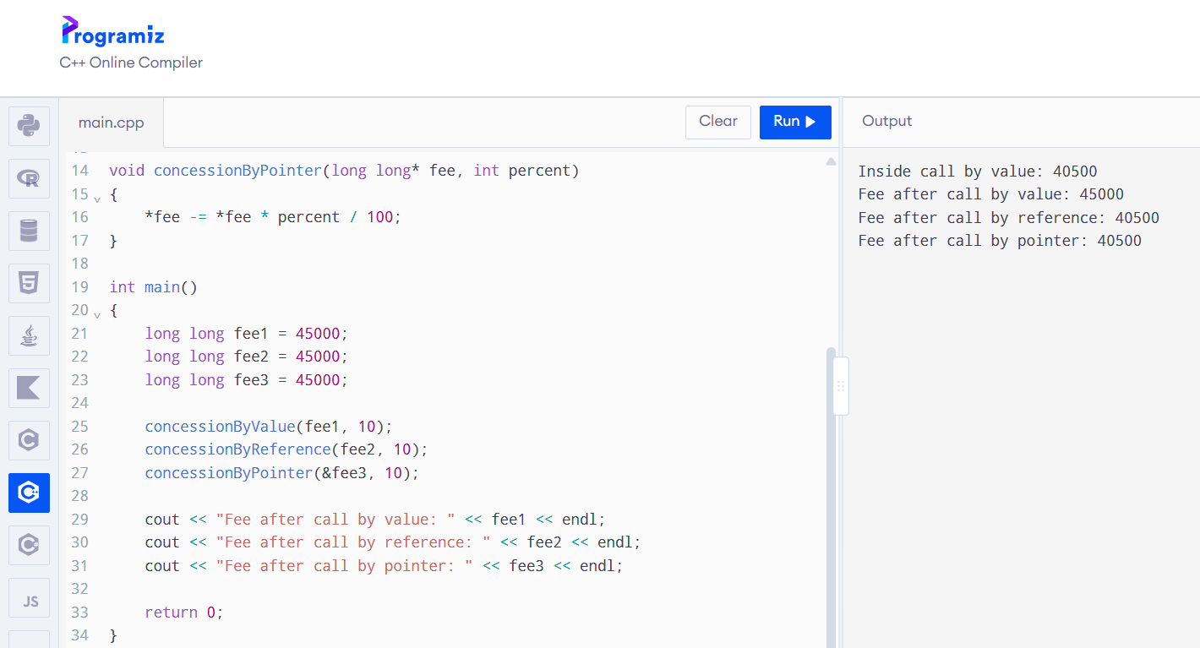7. Explanation
- Call by value creates a separate copy of the fee. Therefore, the original fee remains Rs. 45,000.
- Call by reference directly modifies the original fee. The updated fee becomes Rs. 40,500.
- Call by pointer passes the address of the fee and modifies the original value using the dereference operator.
8. Const Reference Parameter
A const reference is used when a function needs to access an object without modifying it or making an unnecessary copy.
Example:
void displayFee(const long long& fee)
{
cout << fee;
}
The const keyword prevents the function from changing the original value.
9. Complete the Code
#include <iostream>
using namespace std;

void applyByValue(long long fee, int percent)
{
fee -= fee * percent / 100;
}

void applyConcession(long long& fee, int percent)
{
fee -= fee * percent / 100;
}

int main()
{
long long hostelFee = 45000;

applyByValue(hostelFee, 10);

cout << "After call by value: "
<< hostelFee << '\n';

applyConcession(hostelFee, 10);

cout << "After call by reference: "
<< hostelFee << '\n';

return 0;
}
10. Expected Output
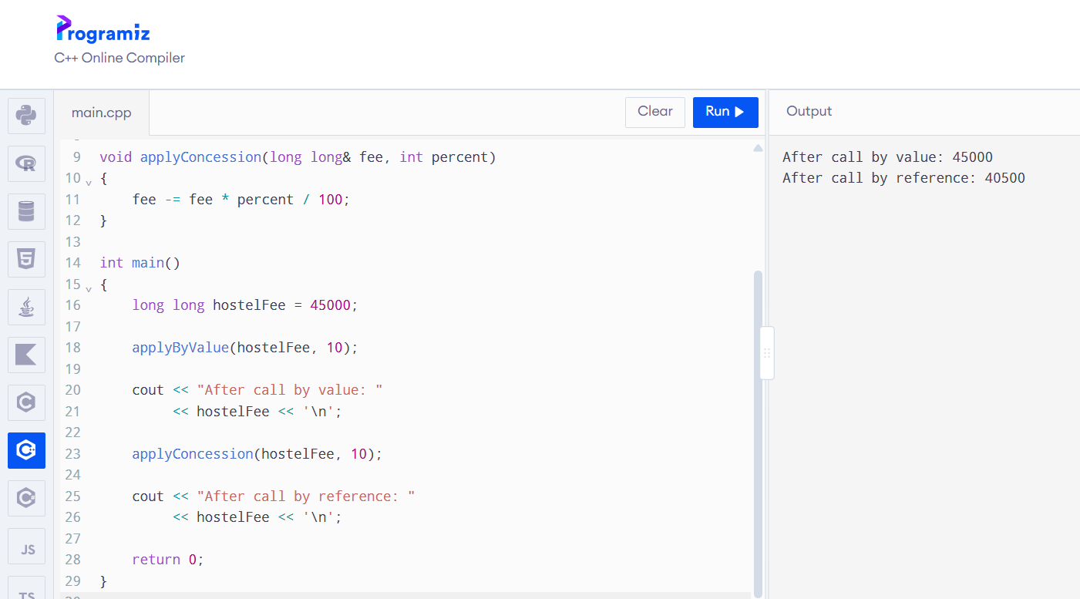11. Alternative Concept and Complexity Analysis
Another approach is to return the updated fee instead of modifying the original variable through a reference.
long long applyConcession(long long fee, int percent)
{
return fee - fee * percent / 100;
}
Function call:
hostelFee = applyConcession(hostelFee, 10);
Both methods have O(1) time complexity because they perform a fixed number of arithmetic operations.
Passing a long long by value copies a small fixed-size value. Passing by reference or const reference avoids copying the value.
Passing a large Student object by value may require copying all its data, while passing it by reference or const reference avoids that copy.
12. Design Decision
When several concessions apply to one student, returning the updated fee is a good choice because each calculation can be performed independently and combined clearly.
For example:
fee = applyConcession(fee, 10);
fee = applyConcession(fee, 15);
However, if the function is designed specifically to update the original student's fee, call by reference is also suitable.
Conclusion: Call by value does not modify the original variable, while call by reference and call by pointer can modify it. Call by reference is a simple and suitable method for updating the hostel fee.

Q2 – RETURN BY REFERENCE AND ITS DANGERS
1. Introduction
In C++, a function can return a value, a reference or a pointer. Returning a reference allows the caller to access and modify the original variable directly.
In an examination marks register, a function can return a reference to the highest mark so that the mark can be modified without copying it.
2. Program to Return the Highest Mark by Reference
#include <iostream>
using namespace std;
int& highestMark(int marks[], int size)
{
int maxIndex = 0;
for (int i = 1; i < size; i++)
{
if (marks[i] > marks[maxIndex])
{
maxIndex = i;
}
}

return marks[maxIndex];
}

int main()
{
int marks[] = {75, 90, 85, 95, 80};

cout << "Highest mark: "
<< highestMark(marks, 5) << endl;

highestMark(marks, 5) += 2;

cout << "After moderation: "
<< highestMark(marks, 5) << endl;

return 0;
}

3. Output
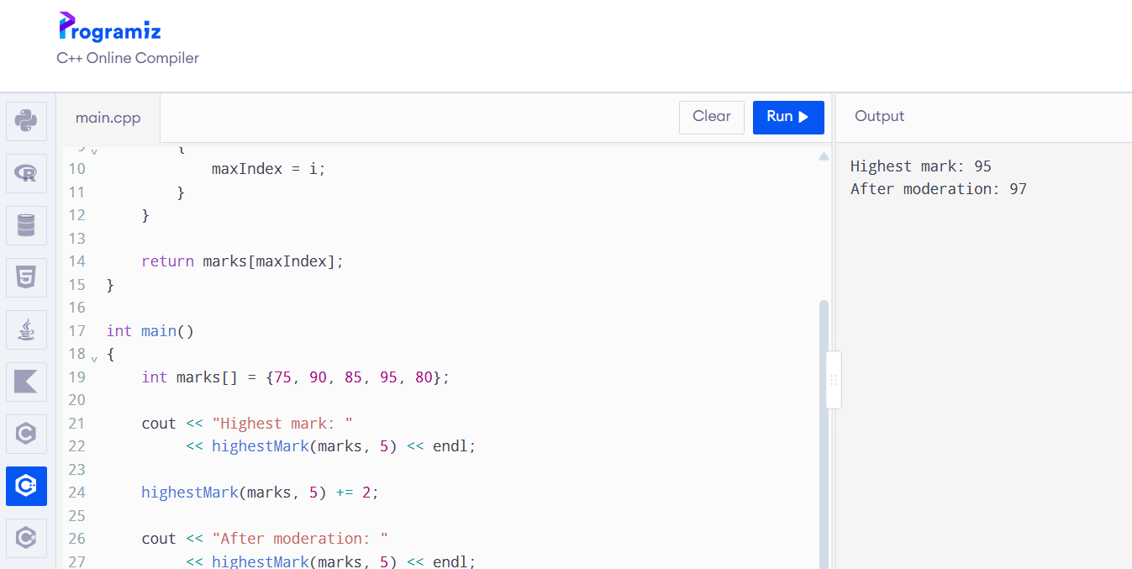4. Explanation
The highestMark() function searches the array and returns a reference to the element containing the highest mark.
The statement:
highestMark(marks, 5) += 2;
directly modifies the original array element.
Therefore, the highest mark changes from 95 to 97.
5. Dangling Reference
A dangling reference occurs when a reference refers to an object that no longer exists.
Example:
int& wrongFunction()
{
int x = 100;
return x;
}
Here, x is a local variable. It is destroyed when the function finishes execution.
Returning a reference to x is invalid because the variable no longer exists after the function returns.
The compiler may produce a warning about returning a reference to a local variable. Using the returned reference causes undefined behaviour.
6. Difference Between Return Types
Return Type | Description
int | Returns a copy of the value
int& | Returns a modifiable reference
const int& | Returns a reference that cannot be modified through that reference
int* | Returns the address of a variable
7. Changed Condition – std::vector
If the marks register is stored in a std::vector, the vector may allocate new memory when additional elements are inserted.
If reallocation occurs, references and pointers to its existing elements become invalid.
Therefore, a reference obtained before vector growth should not be used after an operation that may reallocate the vector.
8. Alternative Concept – Returning an Index
Instead of returning a reference, the function can return the index of the highest mark.
int highestIndex(int marks[], int size)
{
int index = 0;

for (int i = 1; i < size; i++)
{
if (marks[i] > marks[index])
index = i;
}

return index;
}
Calling code:
marks[highestIndex(marks, 5)] += 2;
A pointer can also be returned:
int* highestPointer(int marks[], int size)
{
int* result = &marks[0];
for (int i = 1; i < size; i++)
{
if (marks[i] > *result)
result = &marks[i];
}
return result;
}
Calling code:
*highestPointer(marks, 5) += 2;
9. Complexity Analysis
Finding the highest mark requires checking every array element.
- Time complexity: O(n).
- Auxiliary space complexity: O(1).
Returning a reference, index or pointer does not change the time complexity of finding the highest mark.
Returning an index can be safer when the container may grow because the index can be used to access the element again after growth, provided the logical element ordering has not changed.
Conclusion: Returning a reference is useful when direct modification is required. However, returning a reference to a local variable must be avoided. For a growing vector, returning an index is often safer than retaining a reference across modifications.

Q3 – DEFAULT ARGUMENTS AND FUNCTION OVERLOADING
1. Introduction
Function overloading allows multiple functions to have the same name but different parameter lists.
Default arguments allow a function to use predefined values when the caller does not supply all arguments.
These features reduce repeated code and make functions easier to use.
2. Problem Analysis
The original courier program contains:
double charge(double weight);
double charge(double weight, bool express);
double charge(double weight,
bool express = false,
bool insured = false);
When the function is called with one argument, more than one function may match.
For example:
charge(2.0);
The compiler cannot select a unique overload because all three functions can accept the supplied argument.
This causes an ambiguous function call error.
3. Improved Function Design
The following design uses different parameter types for different kinds of input.
#include <iostream>
using namespace std;
struct Parcel
{
double weight;
bool express;
bool insured;
};
double charge(int grams)
{
return grams * 0.05;
}
double charge(double kg,
bool express = false,
bool insured = false)
{
double amount = kg * 50;
if (express)
amount += 30;
if (insured)
amount += 20;
return amount;
}
double charge(const Parcel& p)
{
double amount = p.weight * 50;
if (p.express)
amount += 30;
if (p.insured)
amount += 20;
return amount;
}
int main()
{
Parcel p{2.0, true, true};
cout << charge(200) << endl;
cout << charge(2.0) << endl;
cout << charge(2.0, true) << endl;
cout << charge(2.0, true, true) << endl;
cout << charge(2) << endl;
cout << charge(p) << endl;
return 0;
}
4. Predicted Output
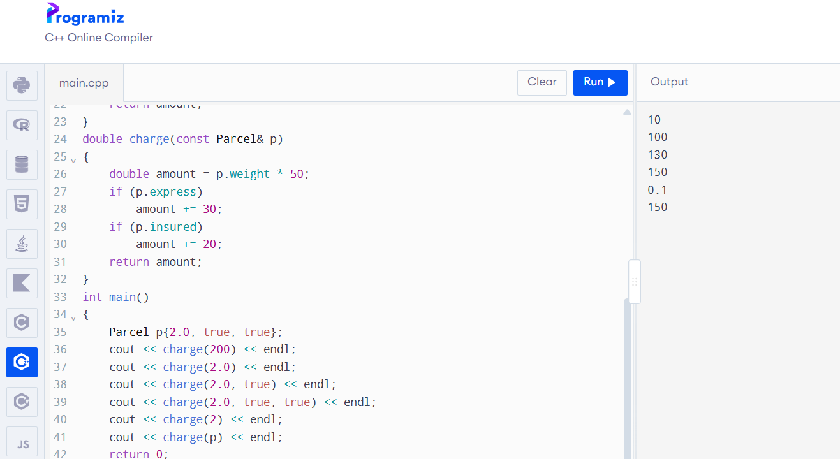
5. Function Selection
Function Call | Selected Function | Reason
charge(200) | charge(int) | Exact integer match
charge(2.0) | charge(double, bool, bool) | Exact double match
charge(2.0, true) | charge(double, bool, bool) | Remaining argument uses default
charge(2.0, true, true) | charge(double, bool, bool) | All arguments supplied
charge(2) | charge(int) | Exact integer match
charge(p) | charge(const Parcel&) | Exact Parcel type match
For an additional test:
charge(2.0f);
The float value is promoted to double, so the double overload is selected.
6. How Overload Resolution Works
The compiler selects the best matching function using the following general preference:
- Exact match.
- Promotion.
- Standard conversion.
For example, converting float to double is a floating-point promotion.
Converting int to double is a standard conversion.
Default arguments supply missing parameters after an overload has been selected. They do not create additional overloads.
7. Why Default Arguments Must Be Given from the Right
Default arguments must be provided from right to left.
Correct:
void display(int a, int b = 10, int c = 20);
Incorrect:
void display(int a = 10, int b, int c = 20);
The incorrect version leaves a parameter without a default after a parameter with a default.
8. Alternative Concept and Complexity Analysis
Another approach is to use a single Parcel structure containing weight, express delivery and insurance information.
This reduces the need for multiple overloads and makes adding new options easier.
A function template is another possible approach when similar operations are required for different types.
Overload resolution happens at compile time, so it does not normally add runtime overhead.
Passing a Parcel by const reference avoids copying its complete contents.
Conclusion: Function overloading and default arguments make the courier charge calculator flexible. Using different parameter types avoids ambiguity and allows the compiler to select the correct function.

Q4 – SPECIFYING A CLASS WITH AN ARRAY INSIDE IT
1. Introduction
A savings account mini-statement stores the last ten transactions made by a customer.
The account must support deposits, withdrawals and transaction display.
Older transactions are discarded when new transactions arrive after the storage limit is reached.
2. Class Specification
The SavingsAccount class contains:

Private Members:
- Account number
- Balance
- Array of ten transactions
- Transaction count
- Circular starting index
Public Members:
- deposit()
- withdraw()
- miniStatement()
The array is private because external functions should not directly modify the transaction records or account balance.
3. C++ Program
#include <iostream>
#include <string>
using namespace std;
class SavingsAccount
{
private:
int accountNumber;
double balance;
string transactions[10];
int count;
int start;
void addTransaction(const string& message)
{
if (count < 10)
{
transactions[(start + count) % 10] = message;
count++;
}
else
{
transactions[start] = message;
start = (start + 1) % 10;
}
}
public:
SavingsAccount(int acc, double amount)
: accountNumber(acc), balance(amount),
count(0), start(0)
{
}
void deposit(double amount);
void withdraw(double amount);
void miniStatement() const;
};
void SavingsAccount::deposit(double amount)
{
if (amount > 0)
{
balance += amount;
addTransaction("Deposited: " + to_string(amount));
}
}
void SavingsAccount::withdraw(double amount)
{
if (amount > 0 && amount <= balance)
{
balance -= amount;
addTransaction("Withdrawn: " + to_string(amount));
}
else
{
cout << "Invalid withdrawal" << endl;
}
}
void SavingsAccount::miniStatement() const
{
cout << "Account Number: " << accountNumber << endl;
cout << "Balance: " << balance << endl;
cout << "Last Transactions:" << endl;
for (int i = 0; i < count; i++)
{
cout << transactions[(start + i) % 10] << endl;
}
}
int main()
{
SavingsAccount account(101, 5000);
account.deposit(1000);
account.withdraw(500);
account.deposit(2000);
account.withdraw(300);
account.miniStatement();
return 0;
}
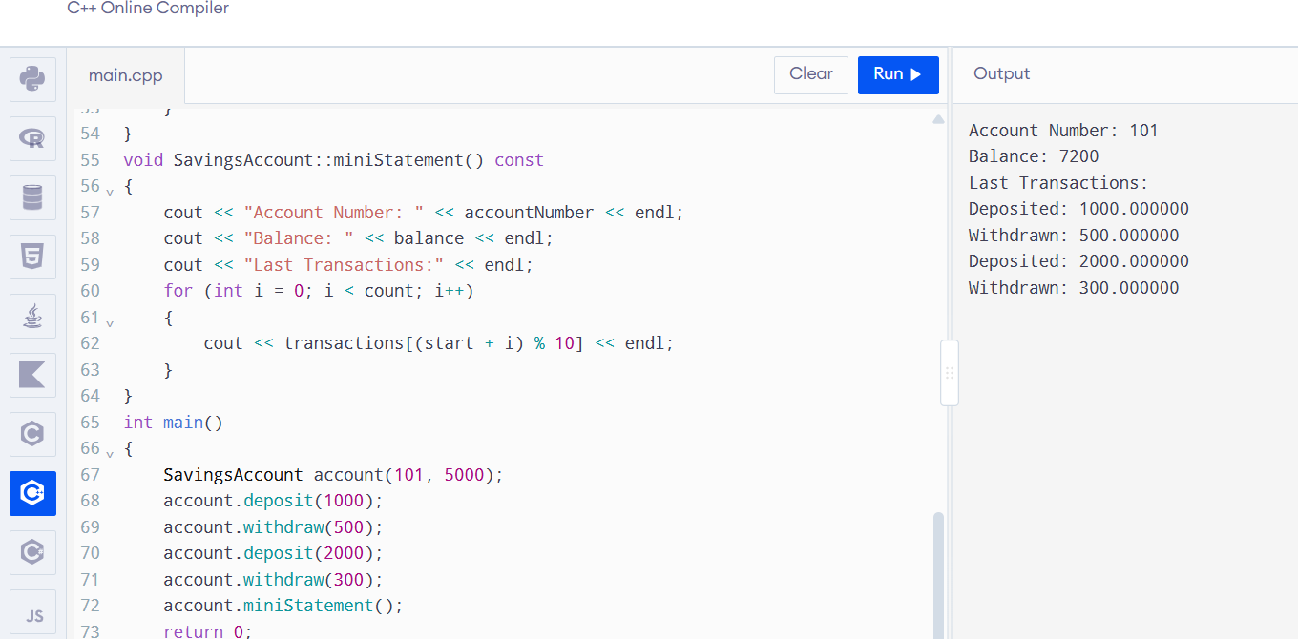
4. Explanation
The account number, balance and transaction array are private.
The deposit() function increases the balance and records the transaction.
The withdraw() function checks whether sufficient balance is available before deducting money.
The miniStatement() function displays the stored transaction history.
5. Handling the 11th Transaction
There are two possible methods.
Method 1: Shifting Array Elements
When the 11th transaction arrives, the oldest transaction is removed by shifting all remaining elements one position to the left.
The new transaction is inserted at the last position.
Time complexity for insertion: O(k), where k is the number of stored transactions.
Method 2: Circular Array
A circular array uses a starting index to identify the oldest transaction.
When the array becomes full, the oldest element is replaced and the starting index moves to the next position.
Time complexity for insertion: O(1).
The circular array is more efficient because it does not shift all elements.
6. Changed Requirement – Last 50 Transactions
If the bank wants to store the last 50 transactions, the array size can be changed from 10 to 50.
A circular buffer can be used with the same logic.
Only the capacity and corresponding index calculations need to be updated.
7. Alternative Concept – std::deque
A std::deque can also store transactions.
When a new transaction arrives:
transactions.push_back(newTransaction);
When the size becomes greater than ten:
transactions.pop_front();
This allows old transactions to be removed from the front and new transactions to be added at the back.
8. Complexity Analysis
Method | Insertion Time | Space
Shifting Array | O(k) | O(k)
Circular Array | O(1) | O(k)
std::deque | O(1) amortised at the ends | O(k)
Conclusion: A circular array is suitable for the mini-statement because it provides constant-time insertion and uses a fixed amount of memory. It is also easy to extend from ten to fifty transactions.

Q5 – STATIC MEMBERS AND ARRAYS OF OBJECTS
1. Introduction
Static members belong to the entire class rather than to individual objects.
In the college bus ticket system, all BusTicket objects share the same seat counter.
The system must assign unique seat numbers until the bus reaches its capacity. Additional passengers are placed on the waiting list.
2. Static Data Members
A static data member is shared by all objects of a class.
Only one copy exists regardless of how many objects are created.
Example:
static int issued;
The static data member must be defined outside the class:
int BusTicket::issued = 0;
3. Static Member Functions
A static member function belongs to the class rather than an individual object.
It can access static data members directly.
It cannot access non-static members directly because it does not have a this pointer.
Example:
static int count()
{
return issued;
}
4. Complete the Code
#include <iostream>
#include <string>
using namespace std;

class BusTicket
{
static int issued;
static const int CAPACITY = 3;

int seat;
string name;

public:
explicit BusTicket(const string& n)
: seat(0), name(n)
{
if (issued < CAPACITY)
{
issued++;
seat = issued;
}
}

static int count()
{
return issued;
}

void print() const
{
cout << name << ": "
<< (seat ? "Seat " + to_string(seat)
: string("Waiting"))
<< '\n';
}
};

int BusTicket::issued = 0;

int main()
{
BusTicket trip[4] =
{
BusTicket("Asha"),
BusTicket("Bala"),
BusTicket("Chitra"),
BusTicket("Dev")
};

for (const BusTicket& t : trip)
t.print();

cout << "Issued: " << BusTicket::count() << '\n';

return 0;
}
5. Expected Output
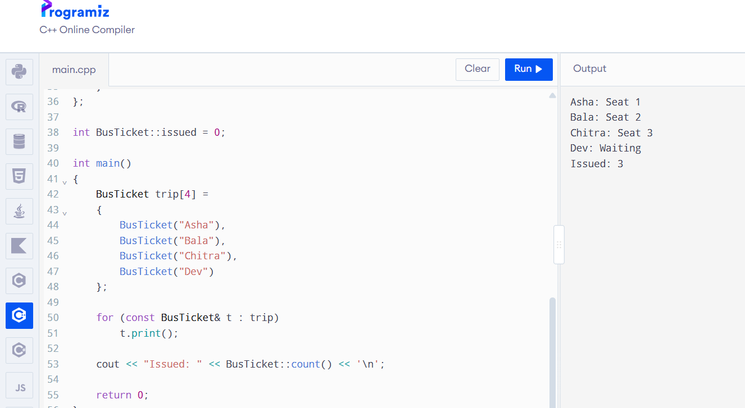6. Explanation
The static variable issued starts at zero.
When the first object is created, the value becomes one and the first seat is assigned.
The second and third objects receive seats two and three.
The fourth object cannot receive a seat because the capacity is three. Therefore, the passenger is placed on the waiting list.
The count() function returns the total number of seats issued.
7. Predict the Output
Program:
#include <iostream>
using namespace std;

class Token
{
static int next;
int id;

public:
Token()
{
id = ++next;
}

int get() const
{
return id;
}

static int issued()
{
return next - 100;
}
};

int Token::next = 100;

int main()
{
Token counter[3];
Token extra;

cout << counter[0].get() << ' '
<< counter[2].get() << ' '
<< extra.get() << ' '
<< Token::issued() << '\n';

return 0;
}
Predicted Output:
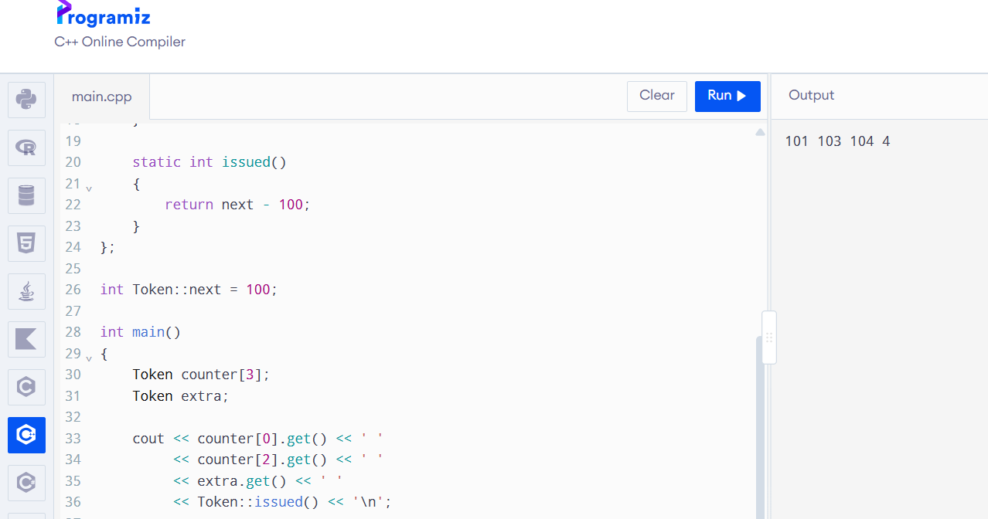8. Explanation
The static counter starts at 100 because it is initialised using:
int Token::next = 100;
Three objects are created in the counter array. Their IDs become 101, 102 and 103.
One additional object is created, so its ID becomes 104.
The constructor runs four times.
The issued() function returns:
104 - 100 = 4.
9. Creating Tickets Inside a Function
void createTickets()
{
BusTicket trip[2] =
{
BusTicket("Asha"),
BusTicket("Bala")
};

for (const BusTicket& t : trip)
t.print();
}
If this function is called twice, four ticket objects are created in total.
The static counter is shared across both calls. It does not reset when the function finishes.
However, the local ticket objects are destroyed when the function returns.
10. Alternative Concept and Complexity Analysis
A global variable could store the number of tickets issued. However, it would be accessible outside the class and could be modified accidentally.
Another method is to create a separate TicketOffice object and pass it to each BusTicket object.
Both methods can provide O(1) time for assigning a seat and use one shared counter.
A static data member provides better encapsulation because the counter belongs directly to the BusTicket class.
A separate TicketOffice object is more flexible when two buses need independent capacities and seat counters.
Conclusion: Static members are useful when data must be shared by all objects of a class. They are suitable for maintaining the issued ticket count and assigning unique seat numbers.

Q6 – FRIEND FUNCTIONS AND INLINE FUNCTIONS
1. Introduction
A friend function is a non-member function that is allowed to access the private and protected members of a class.
In the Train Journey Planner, departure and arrival times are stored in a Time class.
The system must calculate the difference between two times and determine which time occurs earlier.
2. Friend Function
A friend function is declared inside the class using the friend keyword.
It is defined outside the class like a normal function.
It can access private members of the class.
3. C++ Program
#include <iostream>
#include <cstdlib>
using namespace std;

class Time
{
int h, m;

public:
Time(int hh, int mm)
: h(hh), m(mm)
{
}

friend int minutesBetween(const Time& a, const Time& b);

friend bool earlier(const Time& a, const Time& b);
};

int minutesBetween(const Time& a, const Time& b)
{
int first = a.h * 60 + a.m;
int second = b.h * 60 + b.m;

return abs(second - first);
}

bool earlier(const Time& a, const Time& b)
{
if (a.h < b.h)
return true;

if (a.h > b.h)
return false;

return a.m < b.m;
}

int main()
{
Time departure(9, 45);
Time arrival(13, 10);

cout << minutesBetween(departure, arrival)
<< ' '
<< boolalpha
<< earlier(arrival, departure)
<< '\n';

return 0;
}
4. Expected Output
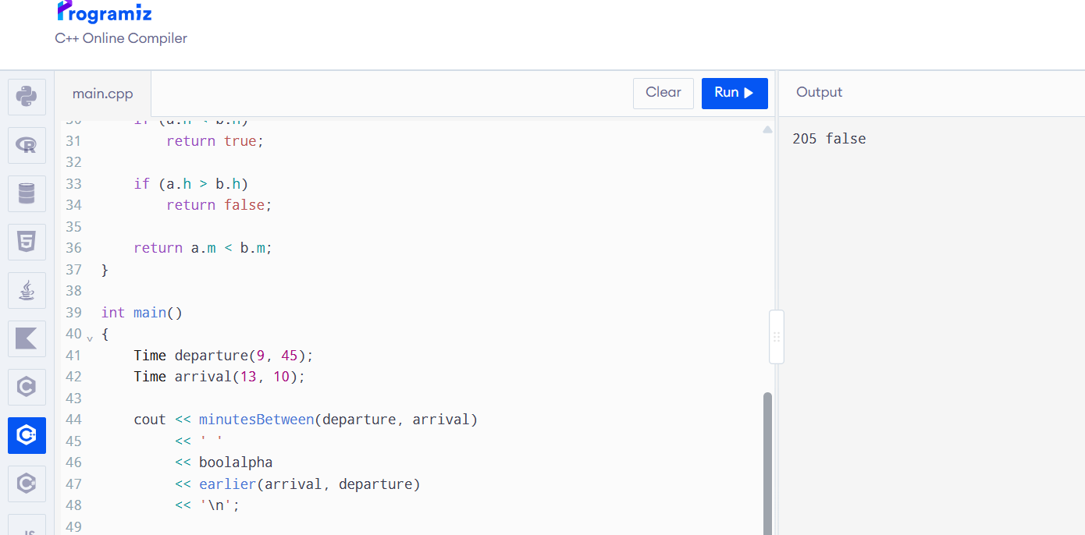

5. Explanation
Departure time is 9:45 AM.
Arrival time is 1:10 PM.
Converting the times into minutes:
Departure = 9 × 60 + 45 = 585 minutes.
Arrival = 13 × 60 + 10 = 790 minutes.
Difference = 790 - 585 = 205 minutes.
The earlier() function checks whether the first time occurs before the second time.
Since arrival is later than departure, the expression returns false.
6. Correctness Tests
Test 1: Same Time
Time a(10, 30);
Time b(10, 30);
Expected result:
0 false
Both times are equal, so the difference is zero and the first time is not earlier.
Test 2: Before and After Noon
Time a(11, 45);
Time b(12, 15);
Expected result:
30 true
The difference is 30 minutes, and the first time is earlier.
7. Why Friend Functions Are Needed
The departure and arrival times are two separate objects.
The minutesBetween() function needs access to private hour and minute values from both objects.
A friend function can access these values directly.
It is called using:
minutesBetween(departure, arrival);
A member function would be called using an object:
departure.minutesTo(arrival);

8. Difference Between Friend and Member Functions
Friend Function | Member Function
Not a member of the class | Belongs to the class
Called like a normal function | Called using an object
Can access private data through friendship | Can access private data directly
Does not have a this pointer | Has a this pointer
9. Inline Functions
An inline function is a function for which the compiler may substitute the function body at the call location as an optimisation.
It can reduce function-call overhead for small functions.
Example:
inline int add(int a, int b)
{
return a + b;
}
The inline keyword does not guarantee that the compiler will replace every function call with the function body.
Functions defined inside a class definition are generally implicitly inline.
10. Alternative Concept – Member Functions
The same operation can be implemented using member functions.
class Time
{
int h, m;

public:
Time(int hh, int mm)
: h(hh), m(mm)
{
}

int minutesTo(const Time& b) const
{
int first = h * 60 + m;
int second = b.h * 60 + b.m;

return abs(second - first);
}

bool isEarlier(const Time& b) const
{
if (h != b.h)
return h < b.h;

return m < b.m;
}
};
Calling code:
cout << departure.minutesTo(arrival);
cout << departure.isEarlier(arrival);
Another alternative is to provide public getter functions for the hour and minute values.
11. Complexity Analysis
Both friend functions and member functions perform a fixed number of comparisons and arithmetic operations.
Therefore:
- Time complexity: O(1).
- Auxiliary space complexity: O(1).
Inline functions may reduce function-call overhead, depending on compiler optimisation.
The actual execution time should be measured using both -O0 and -O2 compiler optimisation settings.
Compilation commands:
g++ -std=c++17 -O0 main.cpp -o program
g++ -std=c++17 -O2 main.cpp -o program
To measure execution time for repeated calls, use the chrono library and run the same workload under both settings.
The measured results depend on the compiler, processor and optimisation settings. They should be recorded after execution rather than assumed.
12. Design Decision
Friend functions are suitable when an operation treats two objects equally, such as comparing departure and arrival times.
Member functions are suitable when an operation is naturally performed by one object using another object as an argument.
The private data should remain private because encapsulation protects the internal representation of the Time class.
Conclusion: Friend functions allow controlled access to private class members. Inline functions may improve the performance of small frequently called functions, depending on compiler optimisation.

Q7 – DIAGNOSE, REDESIGN AND VALIDATE
1. Introduction
A program may work correctly with a small amount of data but become inefficient when the amount of data increases.
The redesign challenge requires identifying a limitation in an existing program and improving its design using suitable C++ concepts.
For this task, the Savings Account Mini-Statement system from Q4 is selected.
A. DIAGNOSE THE LIMITATION
The original mini-statement system stores the last ten transactions in an array.
When a new transaction arrives after the array is full, the shifting-array approach requires moving the existing elements to make space.
If k transactions are stored, inserting a new transaction requires O(k) time.
As the transaction capacity increases from 10 to 50, the number of elements that must be shifted also increases.
This creates unnecessary operations for every new transaction.
The main limitation is the repeated shifting of existing transaction records.
B. DEFINE THE DESIGN OBJECTIVE
The objective is to redesign the transaction storage system so that:
- New transactions can be added in constant time.
- Only the latest 50 transactions are retained.
- The oldest transaction is automatically discarded when the storage is full.
- The balance and transaction history remain accurate.
- The system uses a fixed amount of memory.
The expected improvement is to reduce insertion time from O(k) to O(1).
C. DESIGN THE REVISED SOLUTION
The revised design uses a circular array.
A circular array stores transaction records in a fixed-size array and maintains a starting index.
When the array becomes full, the oldest transaction is replaced by the newest transaction.
The starting index is then moved forward.
Class Design:
SavingsAccount
- accountNumber
- balance
- transactions[50]
- count
- start
Member Functions:
- deposit()
- withdraw()
- addTransaction()
- miniStatement()
Pseudocode:
- START.
- Initialise the transaction array.
- Read the deposit or withdrawal amount.
- Validate the transaction.
- Update the account balance.
- If the transaction count is less than 50:
  - Insert the transaction at the next available position.
  - Increase the count.
- Otherwise:
  - Replace the oldest transaction.
  - Move the starting index forward.
- Display the latest transactions.
- STOP.
D. PREDICT BEFORE IMPLEMENTING
The original shifting-array method takes O(k) time for each insertion when the array is full.
The redesigned circular-array method takes O(1) time for each insertion.
The redesigned method also requires fixed storage for 50 transactions.
The expected result is improved insertion efficiency when the number of stored transactions increases.
E. IMPLEMENT AND VALIDATE THE REDESIGN
Revised C++ Program
#include <iostream>
#include <string>
using namespace std;
class SavingsAccount
{
private:
int accountNumber;
double balance;
static const int SIZE = 50;
string transactions[SIZE];
int count;
int start;

void addTransaction(const string& message)
{
int position;

if (count < SIZE)
{
position = (start + count) % SIZE;
count++;
}
else
{
position = start;
start = (start + 1) % SIZE;
}

transactions[position] = message;
}

public:
SavingsAccount(int acc, double amount)
: accountNumber(acc), balance(amount),
count(0), start(0)
{
}
void deposit(double amount)
{
if (amount > 0)
{
balance += amount;
addTransaction("Deposit: " + to_string(amount));
}
}
void withdraw(double amount)
{
if (amount > 0 && amount <= balance)
{
balance -= amount;
addTransaction("Withdrawal: " + to_string(amount));
}
}
void miniStatement() const
{
cout << "Account Number: "
<< accountNumber << '\n';
cout << "Balance: "
<< balance << '\n';
cout << "Last Transactions:\n";

for (int i = 0; i < count; i++)
{
cout << transactions[(start + i) % SIZE]
<< '\n';
}
}
};

int main()
{
SavingsAccount account(101, 10000);
for (int i = 1; i <= 55; i++)
{
account.deposit(100);
}
account.miniStatement()
return 0;
}
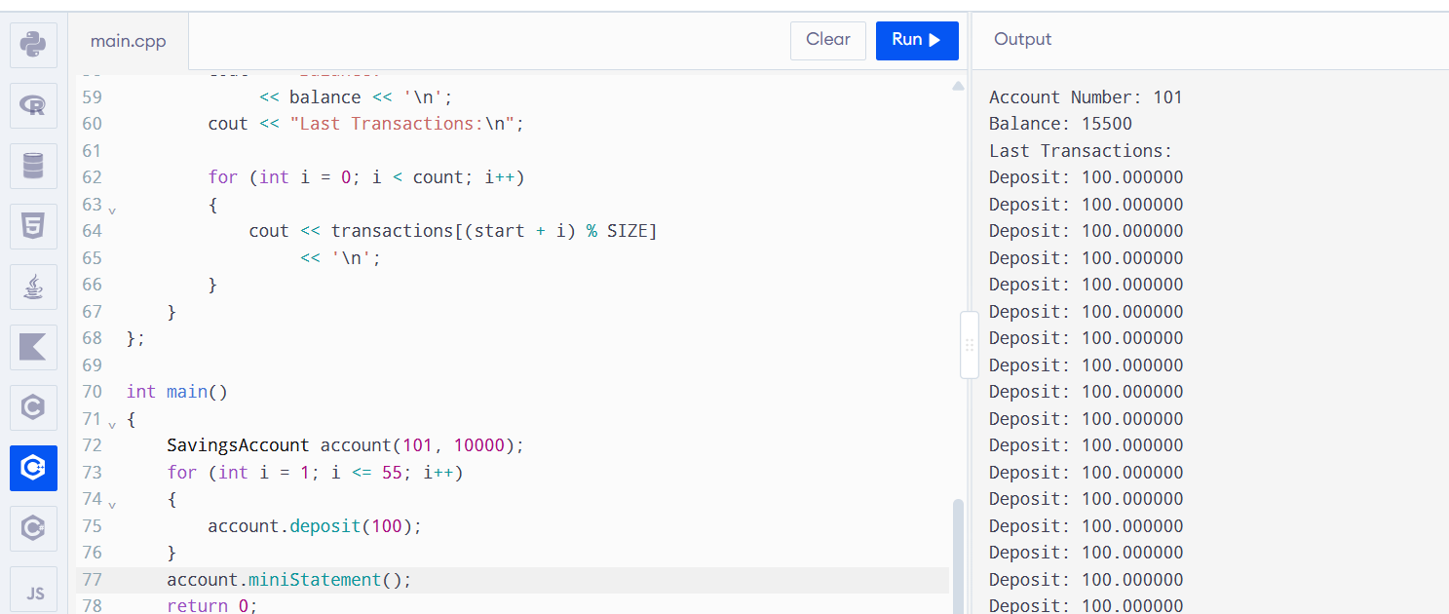
Expected Validation
The program performs 55 deposit transactions.
The storage capacity is 50.
Therefore, the first five transactions are discarded, and the latest 50 transactions are retained.
Initial balance = Rs. 10,000.
Total deposits = 55 × Rs. 100 = Rs. 5,500.
Final balance = Rs. 15,500.
The mini-statement displays only the latest 50 transactions.
F. DEFEND THE FINAL DESIGN
The circular-array design is more efficient because it avoids shifting all existing transaction records when a new transaction arrives.
Comparison:

Feature | Original Shifting Array | Revised Circular Array
Insertion when full | O(k) | O(1)
Memory | Fixed | Fixed
Oldest transaction | Removed by shifting | Replaced using starting index
Implementation | Simple | Requires index management
Performance for frequent insertions | Less efficient | More efficient
The circular-array design requires additional index management, but it provides better insertion performance.
The original shifting-array method may still be suitable for a very small number of transactions when simplicity is more important than insertion performance.
Final Conclusion: The circular-array redesign improves the Savings Account Mini-Statement system by reducing transaction insertion time from O(k) to O(1). It also maintains a fixed memory requirement and automatically retains the latest 50 transactions.

OVERALL CONCLUSION
This assignment demonstrates important C++ programming concepts through practical applications.
Call by value, call by reference and call by pointer explain how functions receive and modify data. Returning references allows direct modification of array elements, while understanding dangling references helps prevent undefined behaviour.
Default arguments and function overloading make programs flexible and reusable. Classes containing arrays help organise transaction records. Static members allow data to be shared across objects, while friend and inline functions support specific access and performance requirements.
The redesign challenge demonstrates how a circular array can improve transaction insertion efficiency compared with a shifting array.
Overall, these concepts help develop C++ programs that are accurate, efficient, reusable and easier to maintain.

REFERENCES
- Bjarne Stroustrup, The C++ Programming Language, Addison-Wesley.
- E. Balagurusamy, Object Oriented Programming with C++, McGraw Hill.
- C++ Reference: https://en.cppreference.com/
- ISO C++: https://isocpp.org/

